***Cardiovascular Health In Teenagers***

**Introduction**

Cardiovascular health is the physical state of an individual’s heart and blood vessels. Cardiac output is the volume of blood pumped by the heart in a minute. Stroke volume is the volume of blood ejected in a pump. Cardiac output (mL/minute) = stroke volume (ml) x heartbeat (beats/minute). Heart rate is the number of times your heart beats per minute (BPM) when you are resting. Measurement of heart rate can be measured several ways, radial pulse which is done by finding the radial artery on the inside of an individual's wrist, carotid pulse using the carotid artery is found on the side of windpipes underneath the jawbone, pedal pulse found by measuring the pulse on top of the individuals’ foot, and usage of a heart rate assistance device smartwatches, blood pressure machines, digital fitness trackers.

The average heart rate for teenagers between thirteen and eighteen is 60 to 100 beats per minute whilst awake. Lower heart rates generally indicate that the heart is more effective at pumping blood, and the individual has better cardiovascular health. There are several variables that can influence an individual's heart rate including; the amount of exercise performed, age, stress, and body size, amongst others. Because exercise trains the body, most specifically the heart muscle; it forces the heart to pump more blood with each beat, therefore more oxygen is delivered to the muscles whilst at rest and consequently will beat less. Thus, teenagers who exercise more frequently should more commonly have lower heart rates. The independent variable is the amount of exercise in hours per week completed by teenagers, the dependent variable is the resting heartrate of adolescents, the controlled variables are the year group participants were taken from, having each participant tested whilst sitting down and how the heart rate is measured and extraneous variables are factors such as anxiety levels, caffeine levels, how intense the exercises are etc.

**Materials and Methods**

**Materials used in the investigation:**

* Stopwatch
* Laptop
* Data collection sheet template
* Internet
* Teenage participants
* Calculator
* Paper
* Pen
* Chair

**Method used for the investigation:**

1. Twenty participants aged between fifteen to sixteen at Southern River College were asked to participate in an investigation. Year eleven students were chosen because they are within teenage years, and twenty were asked to participate to ensure wider variety of data that could be analysed; this was done to ensure validity.
2. Once conditions were agreed upon each participant was asked to be seated and take multiple deep breaths to regulate their heart rate. Being seated ensures there is the same consistent level of activity whilst taking the heart rate.
3. Participants would then be explained how to find their heart rate via the radial pulse method.
4. Each participant would place the pointer finger and middle finger on their wrist just below the thumb, followed by each participant finding their pulse on their wrist. Each participant must take their pulse on their wrist as a controlled variable as it will be the same level of accuracy.
5. A one-minute timer would be set, and subjects would record how many pulses they felt.
6. To guarantee anonymity, each participant's counted number would be written down on a sheet of paper alongside their assigned number once the timer expired.
7. Steps four through six were done twice more for individuals. More data enables for an average heart rate per minute, and repetitive trails improve data reliability.
8. Participants were then asked how many hours of exercise they take per week on average.
9. Participants would then proceed to leave
10. Each of the participants counted number would then be kept track of, with each data set being transferred to a data collection template on a laptop
11. Each participant's data would then be averaged out. Using a calculator their three data sets would be added then divided by three. The average was calculated as many extraneous variables can affect each score.

**Data Table, Graph & Analysis**

**All Collection Data Table**

|  |  |  |  |  |  |  |
| --- | --- | --- | --- | --- | --- | --- |
|  |  | **Resting Heart rate (beats/minute)** | | |  | **GENDER** |
| **Subject (Participant)** | **Exercise (Hr)** | **1st Data** | **2nd Data** | **3rd Data** | **Average** | **Gender** |
| 1 | 6 | 62 | 62 | 64 | 62 | M |
| 2 | 5 | 88 | 77 | 82 | 82 | F |
| 3 | 2 | 72 | 67 | 70 | 69 | F |
| 4 | 0 -1 | 72 | 64 | 74 | 71 | F |
| 5 | 8 | 80 | 76 | 76 | 77 | F |
| 6 | 10 | 104 | 90 | 104 | 99 | M |
| 7 | 2 | 84 | 76 | 72 | 77 | M |
| 8 | 2 | 60 | 56 | 70 | 62 | F |
| 9 | 13 | 84 | 80 | 78 | 80 | M |
| 10 | 6 | 64 | 54 | 59 | 59 | F |
| 11q | 2 | 63 | 52 | 57 | 57 | F |
| 12 | 3 | 77 | 76 | 75 | 76 | M |
| 13 | 10 | 87 | 83 | 88 | 86 | F |
| 14 | 5 | 78 | 78 | 80 | 79 | F |
| 15 | 5 | 80 | 76 | 82 | 82 | M |
| 16 | 3 | 76 | 80 | 72 | 76 | M |
| 17 | 5 | 82 | 98 | 86 | 89 | M |
| 18 | 11 | 69 | 81 | 77 | 76 | M |
| 19 | 11 | 88 | 90 | 80 | 86 | M |
| 20 | 1 | 78 | 77 | 72 | 76 | F |

**Relative Data Table**

|  |  |
| --- | --- |
| **Exercise (Hours) Per Week** | **Average Heart Rate (Beats Per Minutes) BPM** |
| **0** | **No data collected** |
| **1** | **73 BPM** |
| **2** | **61 BPM** |
| **3** | **78 BPM** |
| **4** | **N/A** |
| **5** | **83 BPM** |
| **6** | **60 BPM** |
| **7** | **N/A** |
| **8** | **78 BPM** |
| **9** | **N/A** |
| **10+** | **88 BPM** |

**Hand Drawn Graph (Submit In- Person)**

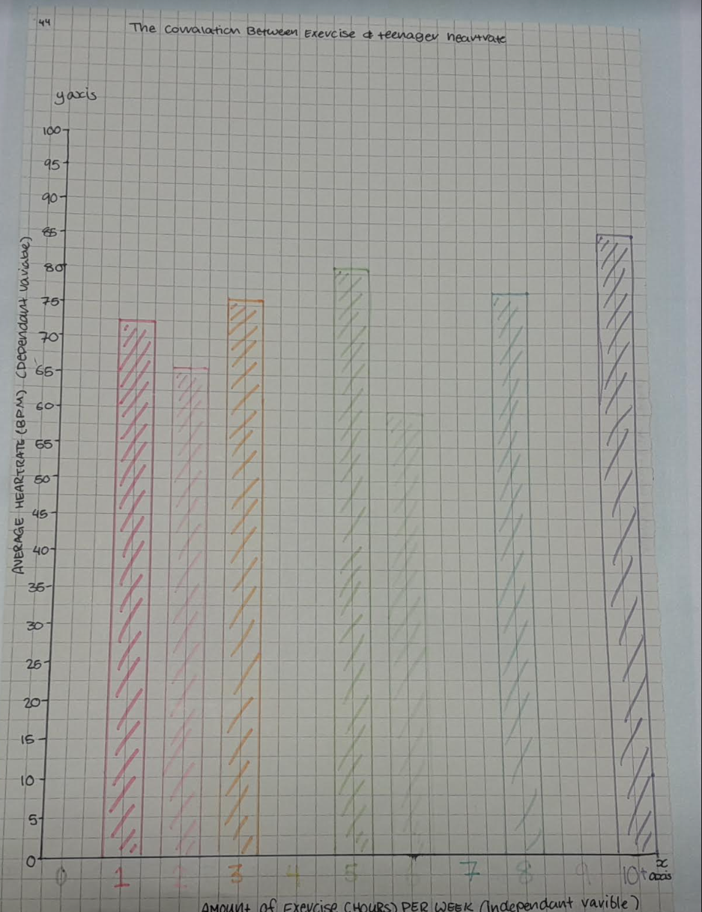

The data obtained in the table was then grouped by the number of hours of exercise done per week, so those who engaged in one hour of exercise are grouped with those who exercised one hour per week, and so on. Each group's average was then combined again to produce one average resting heart rate. This was then matched with how many hours of activity were accounted for in the final average figure. The graph demonstrates that there is not a wide range of data because several sections are absent due to a lack of participants exercising during that time frame. During data gathering, a noticeable outlier, in subject six, with comparatively high scores, was not included in the graph to guarantee validity due to an outlier drastically altering the average.